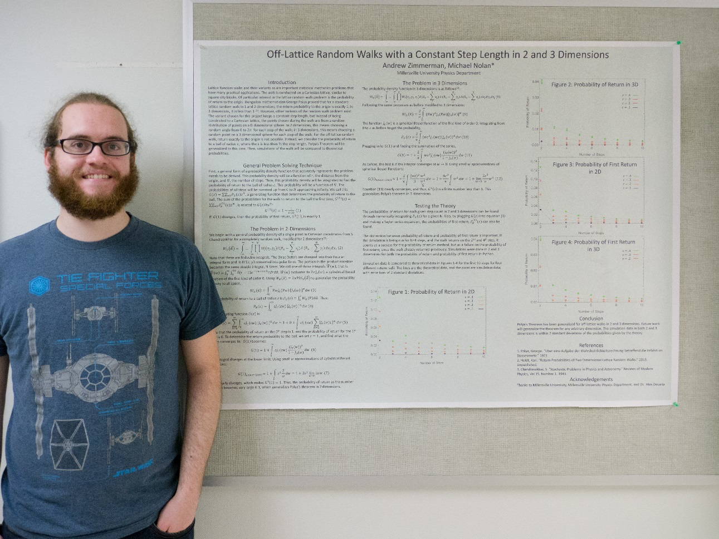
Off-Lattice Random Walks in 2, 3, and Higher Dimensions
Andrew Zimmerman
Advisor: Dr. Michael Nolan
The return probabilities and other aspects of lattice random walks are well known. For a lattice random walk with isotropic probabilities, the return probability to the origin of the walk will be one in both one and two dimensions as proven by Hungarian Mathematician George Pólya. However, less is known about off-lattice random walks. This paper discusses off-lattice random walks with a constant step length of 1. Also, Pólya’s theorem for lattice random walks will be generalized to the off-lattice case with a return region in the shape of a circle or sphere, generally called a ball. The probability of return to a ball of radius ε<12 is 1 for lattice free walks in 2 dimensions, and less than 1 in 3 dimensions. Simulations of the first 10 steps of the walk will be run in both 2 and 3 dimensions and compared to the theoretical data. A generic form of the probability for D dimensions will also be derived.

