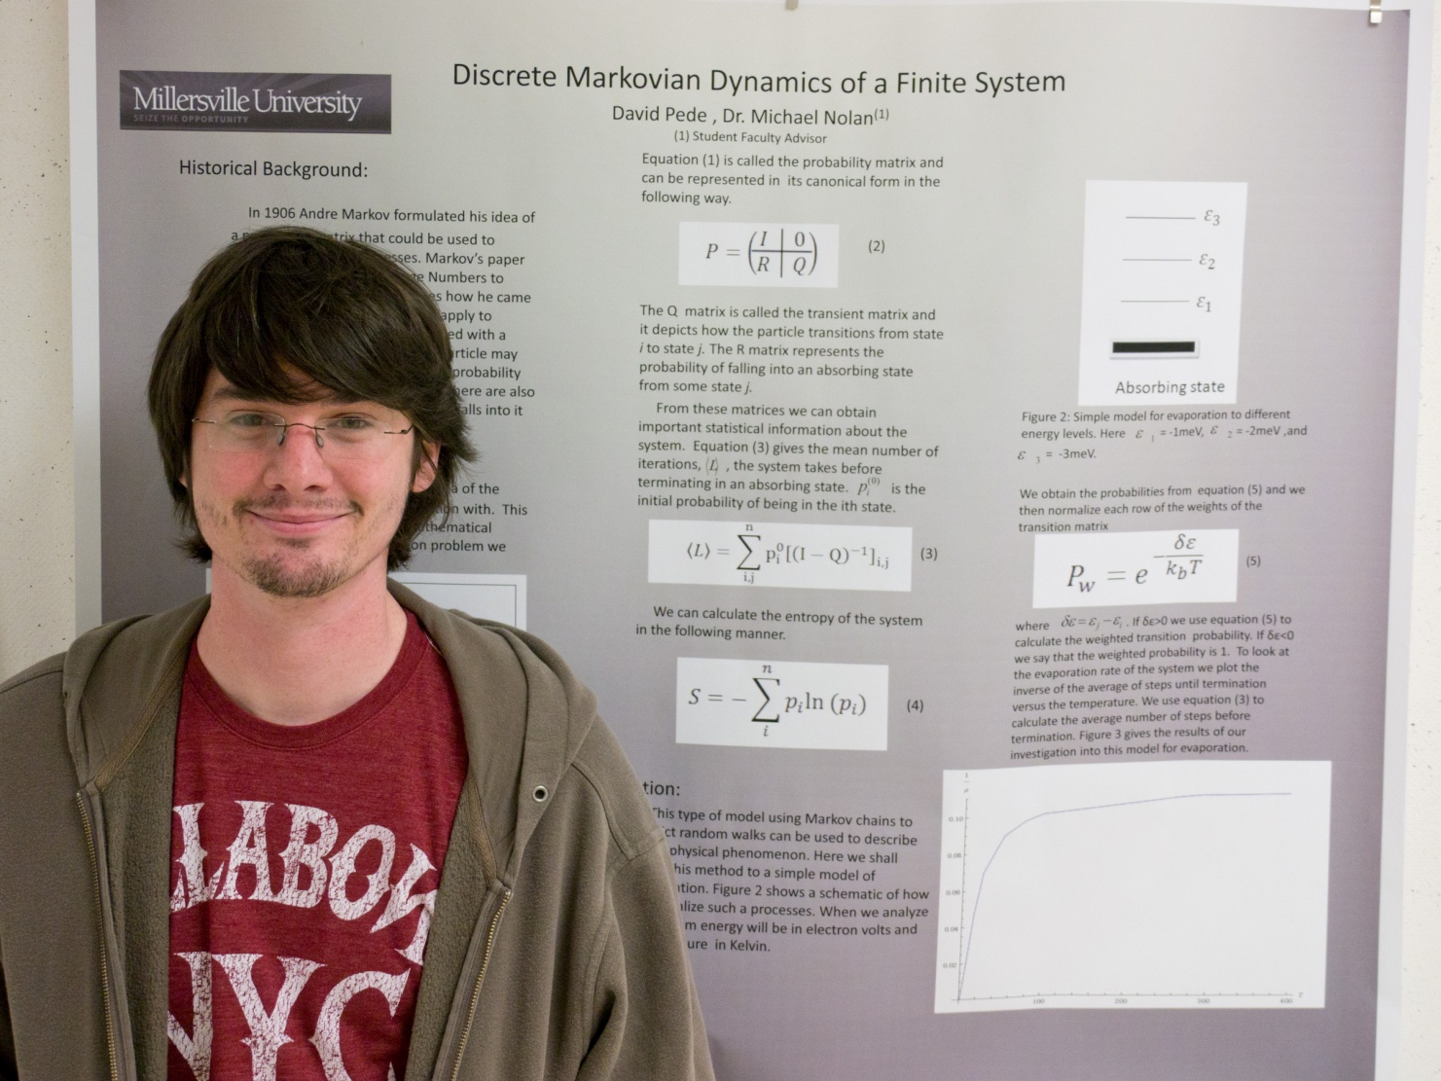

Discrete Markovian Dynamics of a Finite System

David Pede
Advisor: Dr. Michael Nolan

In 1906 Andrey Markov formulated his idea of a probability matrix that has been used to describe stochastic processes. In this paper we will master the basics of Markov chains and simulate simple systems. After giving a mathematical overview of what Makrov chains are we will then apply them to single particle systems. From there we will use the mathematics of Markov chains to analyze the number of steps the system takes before terminating as well as deriving the moment generating function for each process. The end result from this will be the ability to predict and analyze stochastic processes in physics using this method of Markov chains.

