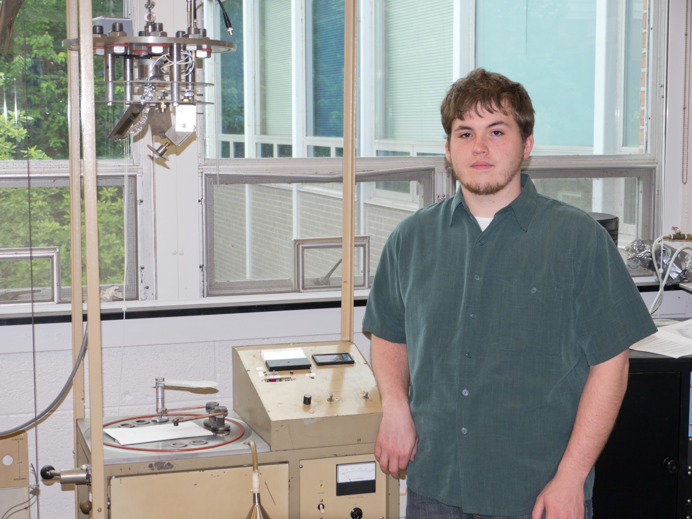

Conductivity of Chromium Sculptured Thin Films

Cody Johnson

Advisor: Dr. Tariq Gilani

This paper discusses the conductivity found in Chromium Sculptured Thin Films (STFs) perpendicular to column growth. Chromium STFs can be modeled as inductors and capacitors in series. The methods of verification for this hypothesis will be explored in length in this paper, as well as trying to develop a theoretical model that describes this situation. This paper will also look at the anisotropy of the material’s resistivity and the method of developing a working model that fits.

